CLOISONNÉ Tutor Ruth Ball

Overview
The general consensus states that Cloisonné, meaning "to partition" in French, is one of the very oldest enamel techniques. Speculatively it’s origins were perhaps developments of filigree and early stone setting methods. Glass and semi precious stones were set into jewels as a replacement for more costly precious stones. The fine wires regularly partitioned segments of cut, often complex, finely shaped materials to add richness and elaborate adornment.

Early examples of true enamel artefacts date from the Mycenaean period. The technique was adopted by the Greek and Italian civilisations and then technique then spread through Europe. The style particularly flourished in the Byzantine Empire, and it was used as a favoured technique throughout the Middle Ages.
China and Japan excelled in the art of cloisonné in later periods. The cloisonné technique is often associated with the methods, and the characterised imagery, employed by their highly skilled craftsmen. Cloisonné is generally typified and remembered by many as a style of these areas, due in part to the prodigious export of enamelware from these continents.

The fusing of fine wires, to a base coat of enamel, creates the method. The design is built up by placing the various enamel colours into the cells that are formed by the wires. There are variations in technique, but cloisonné is perhaps the easiest of the traditional methods to learn and develop. The cloisonné style can be best described as linear. It traditionally looks fairly complex, however, the bending and forming of wires either by hand using basic hand tools, or simple formers, provides a straightforward format for the creation of a design.

Cloisonné can be used in many ways, forming pattern or enabling illustrative and expressive effects. Noticeably, the wire creates lines that form fluid, hand drawn qualities, thus combing the integral use of colour and design. Partitions of enamel woven together with finely banded ribbons of metal have the potential to create exquisite combinations.
As with each method of enamelling there are many possibilities for the portrayal of idea and imagery and the technique may be employed for a wide range of surface embellishment.

WIRES FOR CLOISONNÉ
Cloisonné wires can be fashioned from copper, silver, or gold.
Traditionally wires are rectangular, although in contemporary ware round wires are often used.
It is also possible to forge, file and shape irregular sections of wire to fuse into the enamel for more free-form /expressive drawn effects. The wires for all methods are very fine. It is possible to use different diameters of wire. It is worth making samples to explore the quality and thickness of line and the different enamel depth that is achieved.

Round wire:
- Round wire, is easier to shape and stays in place more readily. The depth achieved using round will depend on the diameter of wire used. Extremely fine round wire of 0.1mm is suitable only as a surface effect, whereas 0.3 is a good general size to work with. Round wire of 0.5mm, possibly the thickest round diameter that is of general use, will achieve greater depth to transparent colours.
- Round wire can be hammered into flat wire for additional effect. This is particularly useful if you require a finer line.

Rectangular wire:
- Rectangular wires are generally 0.2mm or 0.3mm thick and around 1.5mm deep, although there are several variations available. Rectangular wires allow for greater thickness of enamel.
Rectangular wire methods can be used for a variety of effects, and they are lovely used in shaded techniques.
Problems with positioning and balance can be easily overcome via a combination of methods. Using a gum /
holding agent to position the wires is beneficial and cutting off small tabs into the rectangular strip provides
stable anchors within the design, helping the wire to stand in place whilst firing.

- All cloisonné wires should be annealed and cleaned before shaping and placing onto the enamel surface.
Generally, fine silver or fine gold round wire is normally used, the higher carat metals require little cleaning once
annealed.

>> Use fine gold wire - Only higher carat gold, or gold alloys of an enamelling quality should be used. Don’t be tempted to economise and by lower carat golds.

>> Never use an alloy that contains zinc or nickel

>> Note also that if you are using copper wire it will need to be cleaned after each firing as the fire scale will flake off and affect the enamel.

GENERAL CONSTRUCTION
Cloisonné can be added to champleve cut shapes, press formed articles two and three-dimensional forms and a variety of constructional methods can be encountered. Several factors are integral to the development of an enamel jewel. The choice of metal, the desired shape / form, fittings, and the relative metal thickness needs to be determined. The main concern with most work will be the strength of the piece, its wearablity, and typically the protection of the enamelled edge. If a piece is not protected by a rim of metal as in the champleve technique, it will need to be set.
The options will vary as per your design. Consider all possibilities and make sure that the fittings and settings you choose are complimentary to your design.

PREPARATION
Following the appropriate cleaning method for the metal you are using your piece should be thoroughly cleaned of fire scale or fire stain and de greased.
Counter enamel should be applied if necessary. Counter enamel should be of a similar firing type to the enamel used on the front of the piece. Flux or a contrasting colour can be used. Consider the counter enamel carefully if it is to be seen from the back of the piece in a setting.
A Based Coat of enamel flux should also be fired into the work. Flux is ideal as it provides a neutral layer for the subsequent enamel colours, however an alternative base enamel of your choice, as per the requirements of your design can be used.
- It is possible; if you grind your counter enamel finely you can fire the front and back in one firing. Gum is useful to help the counter enamel remain on the back of the piece when firing, (but it is best not used on the front layer as it can affect some colours) Apply a thin coating of klyre fire to the reverse metal surface before applying the enamel. You can then enamel the top base coat at the same time, firing with the front of the piece uppermost. If any enamel drops from the back of the piece repeat the metal cleaning, re apply the enamel and then fire. If the counter enamel dries whilst enamelling the top base layer you can spray klyre fire over the back again to re hold the particles. (Dry everything off before firing though)
- It is recommended to fire an additional base layer of enamel, and the stone it back with carborundum / diagrit. Re firing to attain a smooth surface onto which you fuse your wires. (This is particularly important if you are using copper as a base and silver wires. There needs to be a good depth of enamel in order that the silver does not contact the copper, otherwise an eutectic reaction occurs - the two metals fuse forming an alloy and the piece becomes unworkable The wires melt into the base, rather unattractively.)

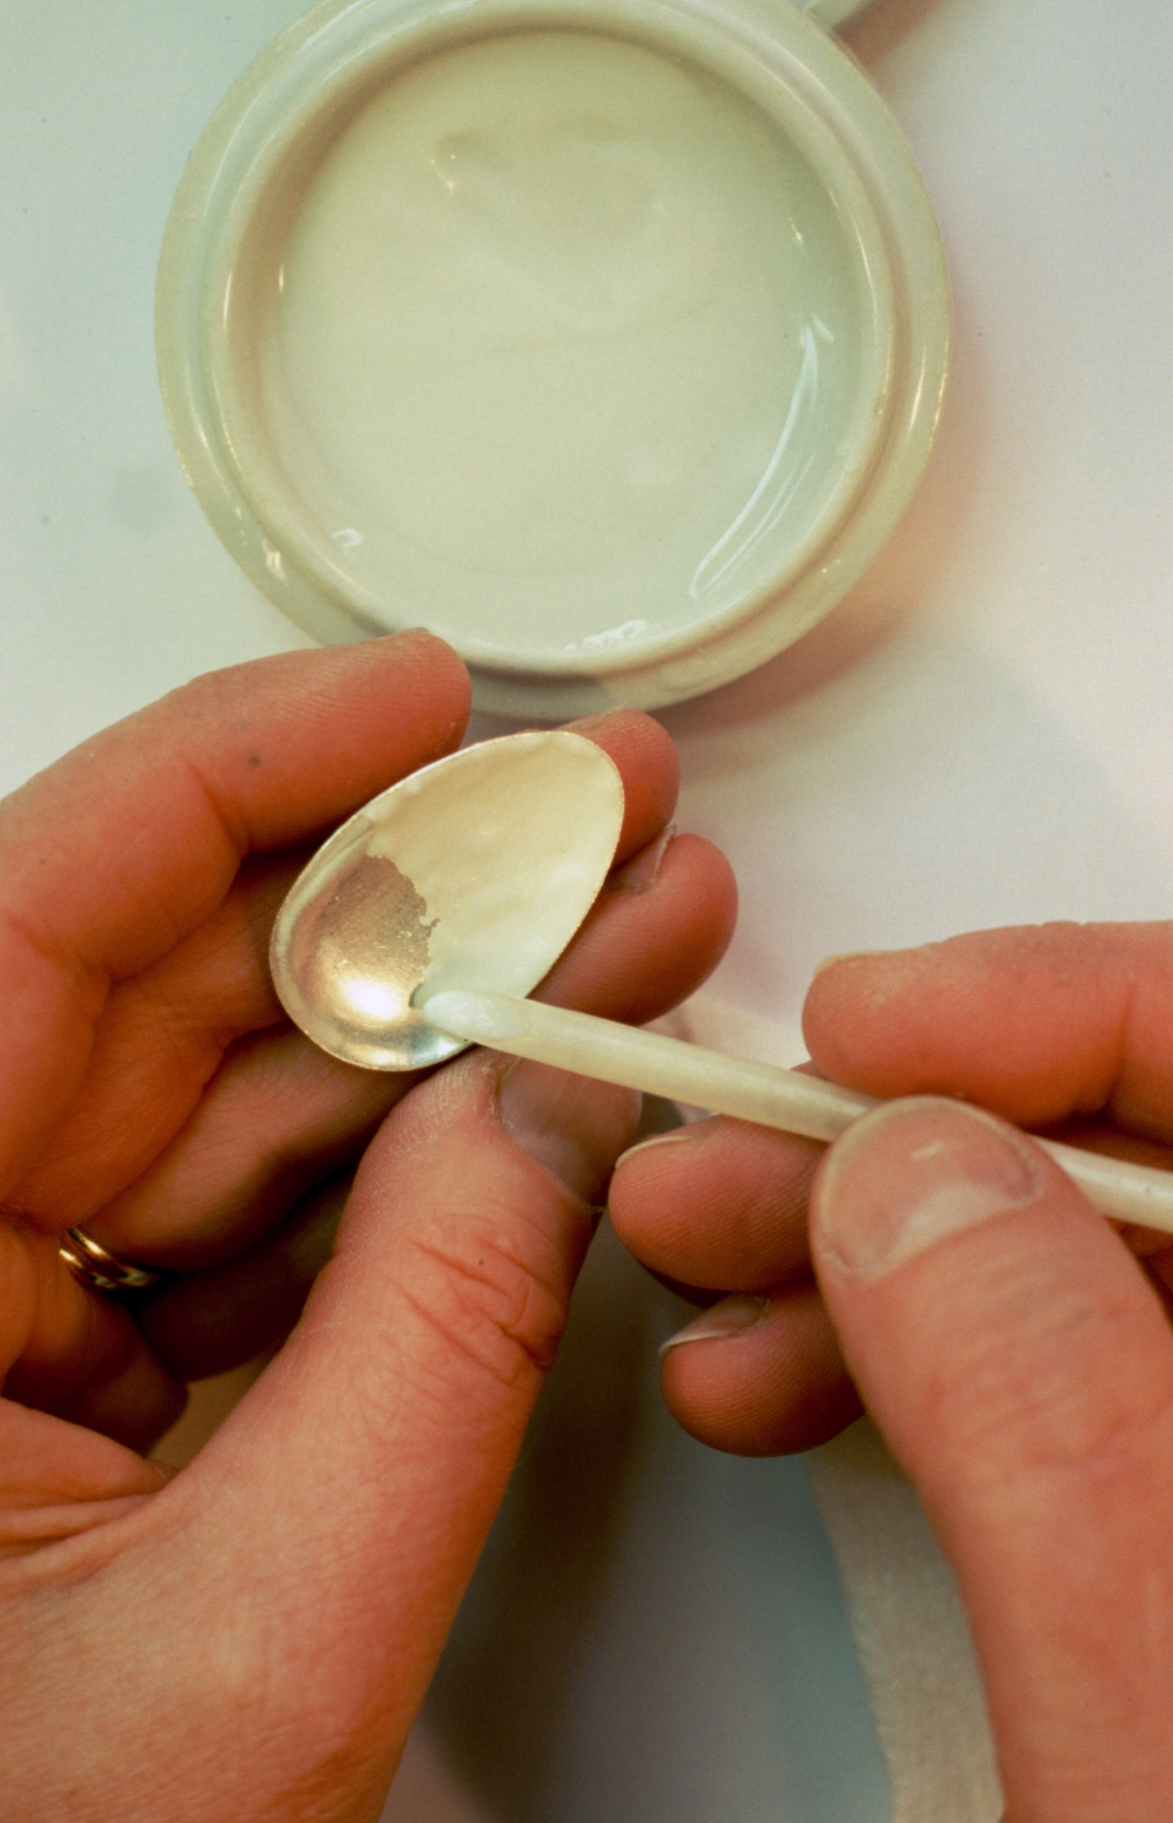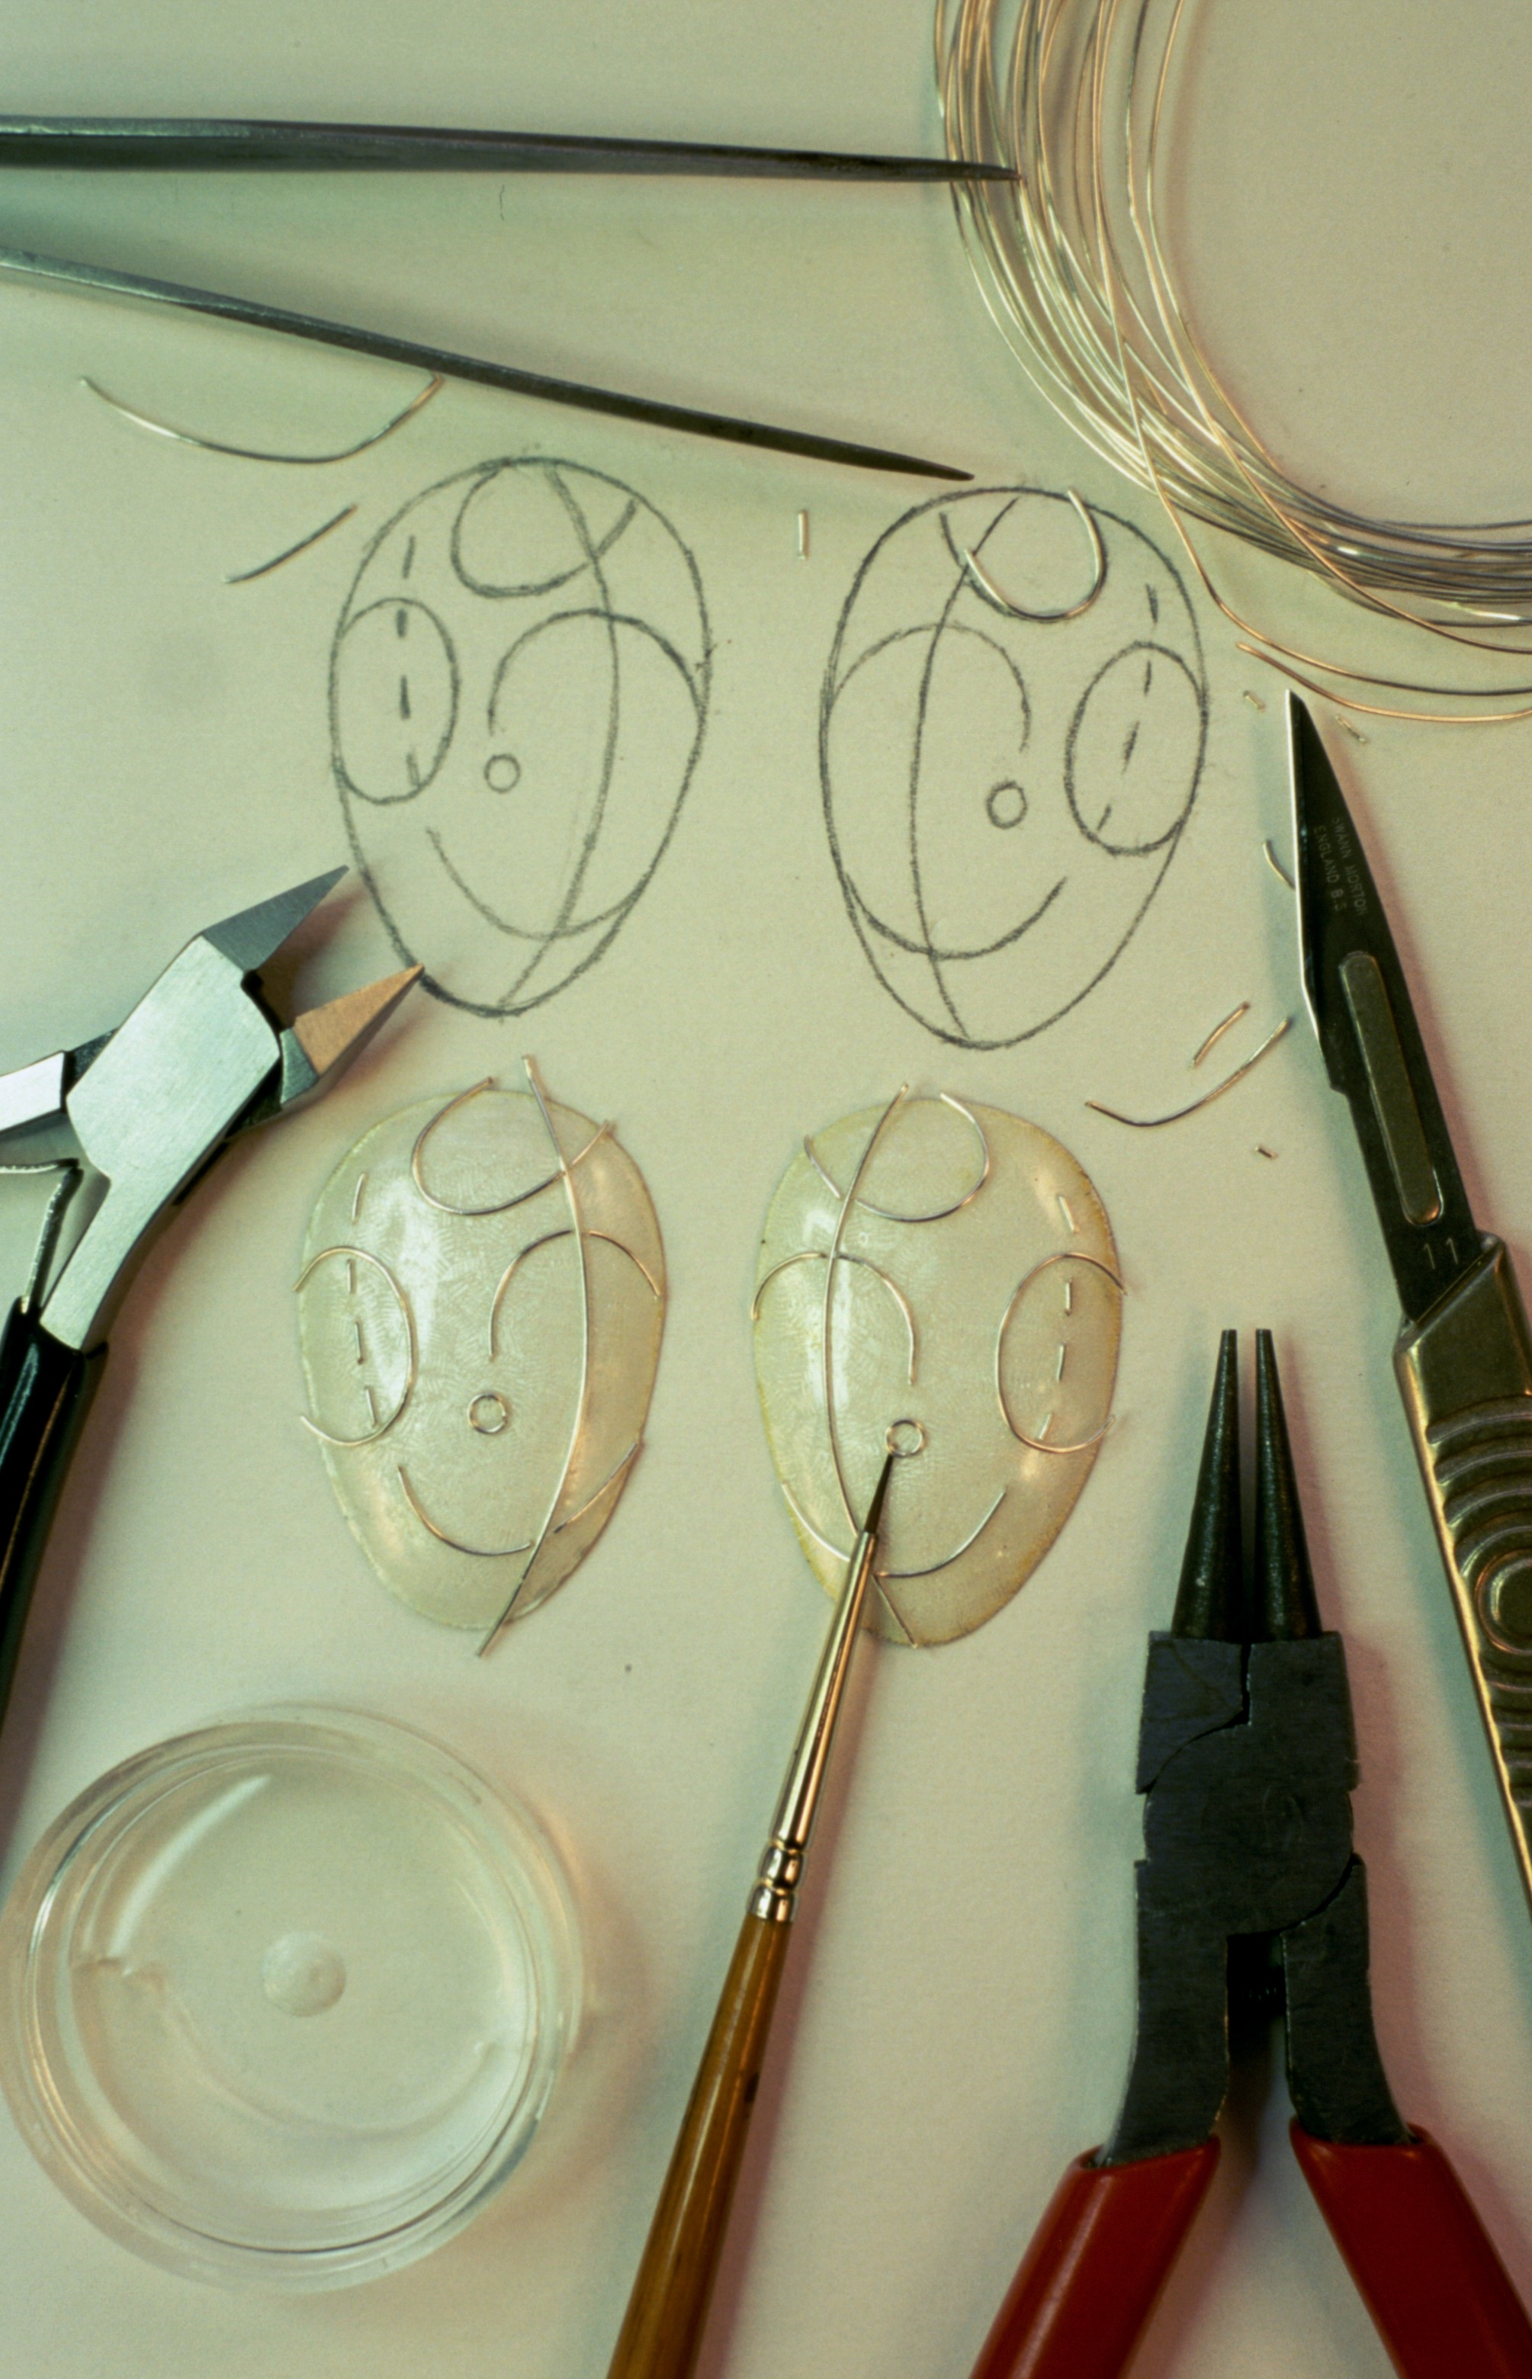
Applying flux as a counter enamel Forming and shaping wires with pliers

continued...

SHAPING THE WIRES

Generally, the shaping of wires is done by hand. Wire can be bent very easily with your fingers and simple shapes can be formed with a selection of hand pliers. However for repeated shapes and elaborate sections tools can be made.

- Copper or brass can be cut to shape to make a tool that will make repeat shapes
- “Peg boards” can be used as guides for wire formation.
- MDF can be cut to shape and used a simple former.
- Paper crimper’s are a quick and fun way of creating zig zag lines

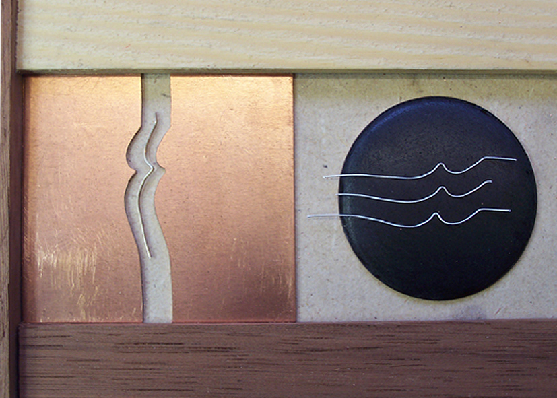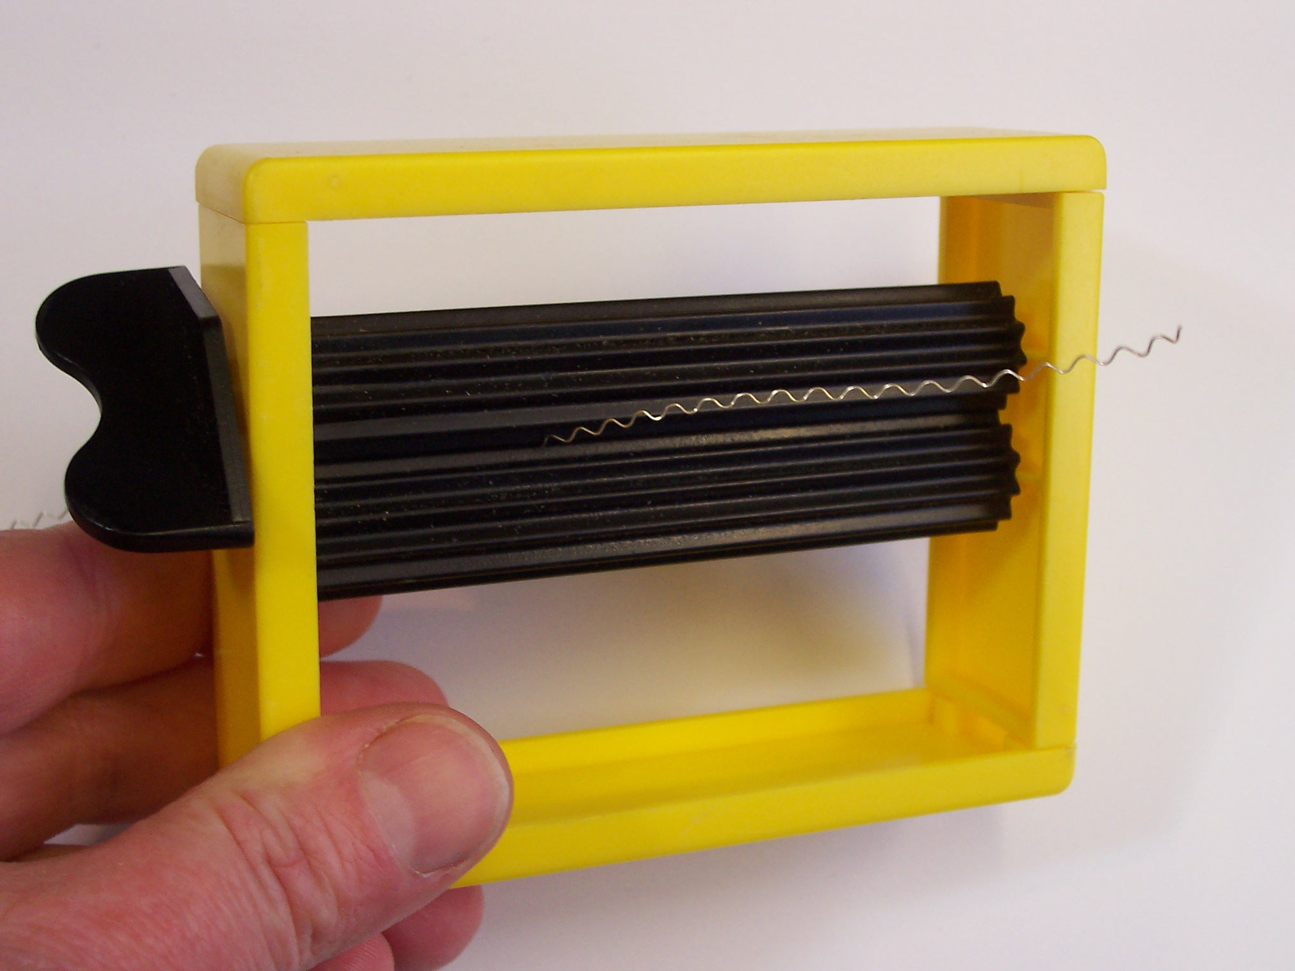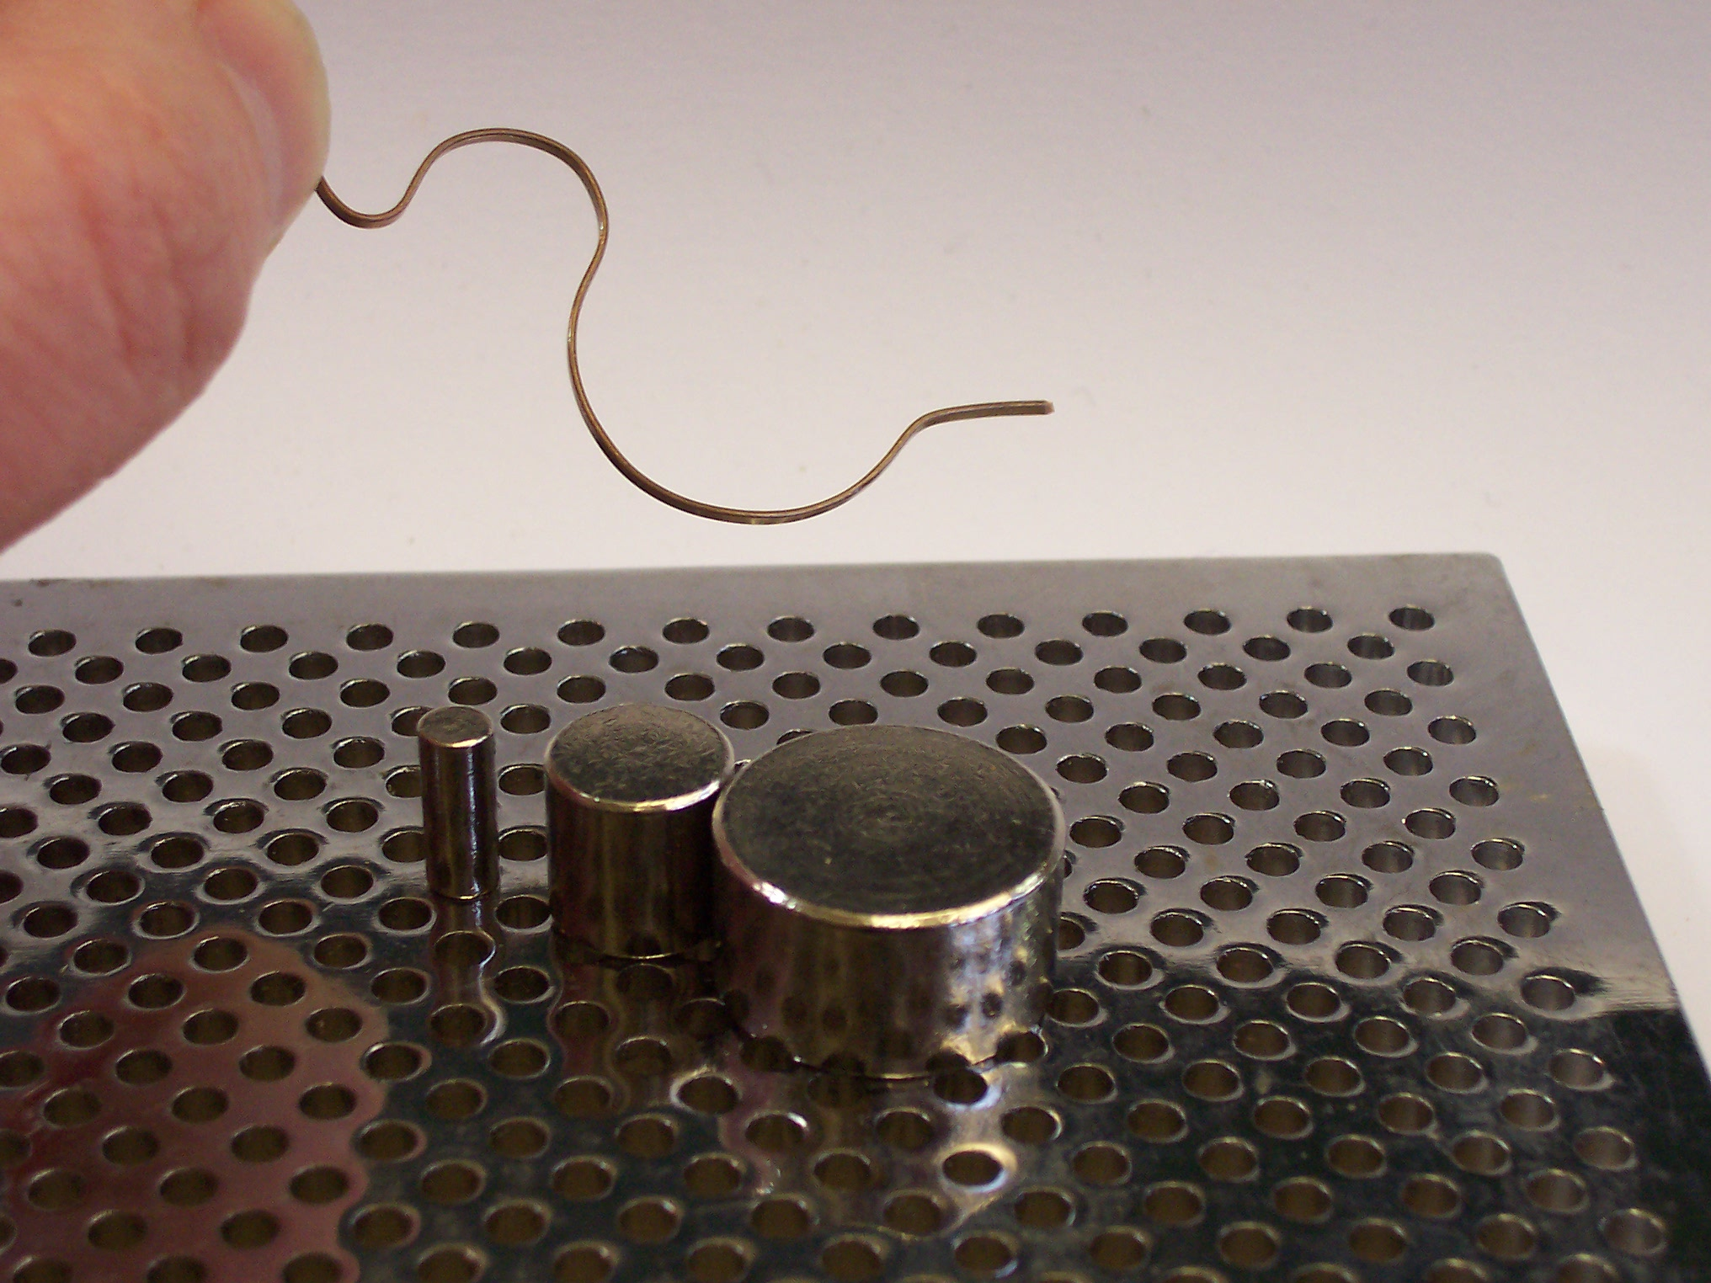
Handmade former made from copper sheet. Commercially made paper crimper Commercially made peg system

TRANSFERRING THE DESIGN
The wires are positioned carefully over the flux / base layer with a fine brush or tweezers. They are then fired in the kiln to fix them into place. The wire fuses into the surface of the flux to provide a cell structure for more enamel to be applied.
- You can use tracing paper / acetate paper over your design outline with a layer of double sided tape. This provides a clever support to the wires when building up the wire image. The design is thus easily constructed and ready to transpose onto the enamel.
- A transfer using an engraved copper plate and sellotape can be useful for enamelling repeat designs.
- Or you can simply draw freehand onto you fired base layer with a felt tip pen to mark out your design – the lines made with the felt pen will fire away when heated in the kiln.

PLACING THE WIRES
- Use klyre fire and a fine paintbrush to position the wires and keep them in place whilst firing.
- Ensure that wires meet neatly, butt them together, filing ends if needed.
- When firing dry the klyre fire of gently before placing the piece fully into the kiln.
- Warm the piece gently and watch carefully to check if any wires move – if they do re position and try again.
- Care must be taken on the initial firing not to over fire, as the wires will over sink into the base layer and become receded.
- If you are using different gauges of wire in the same piece, fire the thickest gauge first. Then apply a second layer of enamel before adding the finer wires. Very fine wire should only be applied in the last couple of firings.

FILLING THE CLOISONNÉ CELLS

First layer of Colour
Colours should be full ground and washed, as per requirement, then applied in thin layers covering the appropriate areas of the design. A quill or fine brush is used to apply the enamel. Once the area is covered the piece is tapped gently to remove any trapped air, dried with a tissue to remove moisture and then fired in the kiln.
More layers
As with most techniques another two or three layers are applied and fired until the enamel is flush with the top level of the wires. It is necessary to build up the enamel in thin even layers firing each layer separately. It’s important to remember if using the wet packing technique that each application should be dried with absorbent tissue before firing in the kiln.
The repeated fired layers build up the depth of colour and avoid any problems caused by too thick a layer being fired. If the enamel is applied too thickly it characteristically “ball’s up” or can cause air pockets, resulting in holes or chipping.

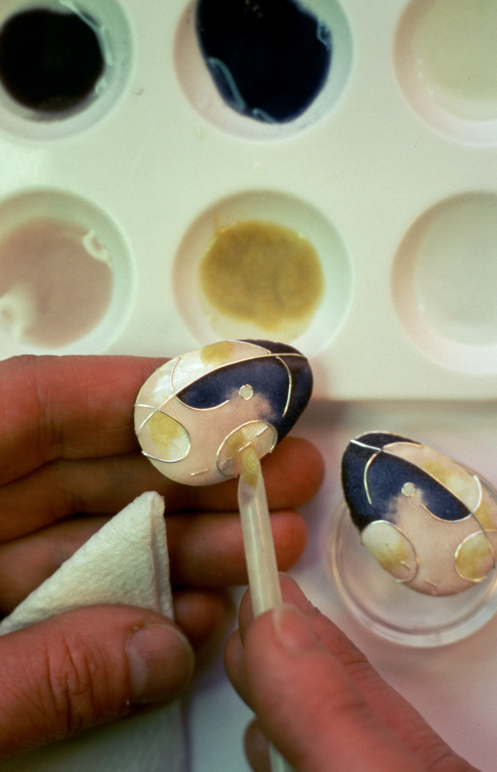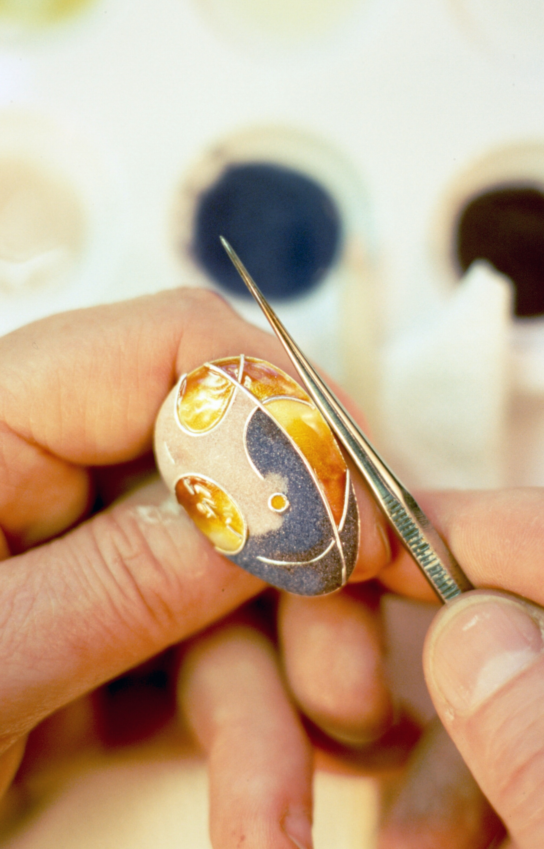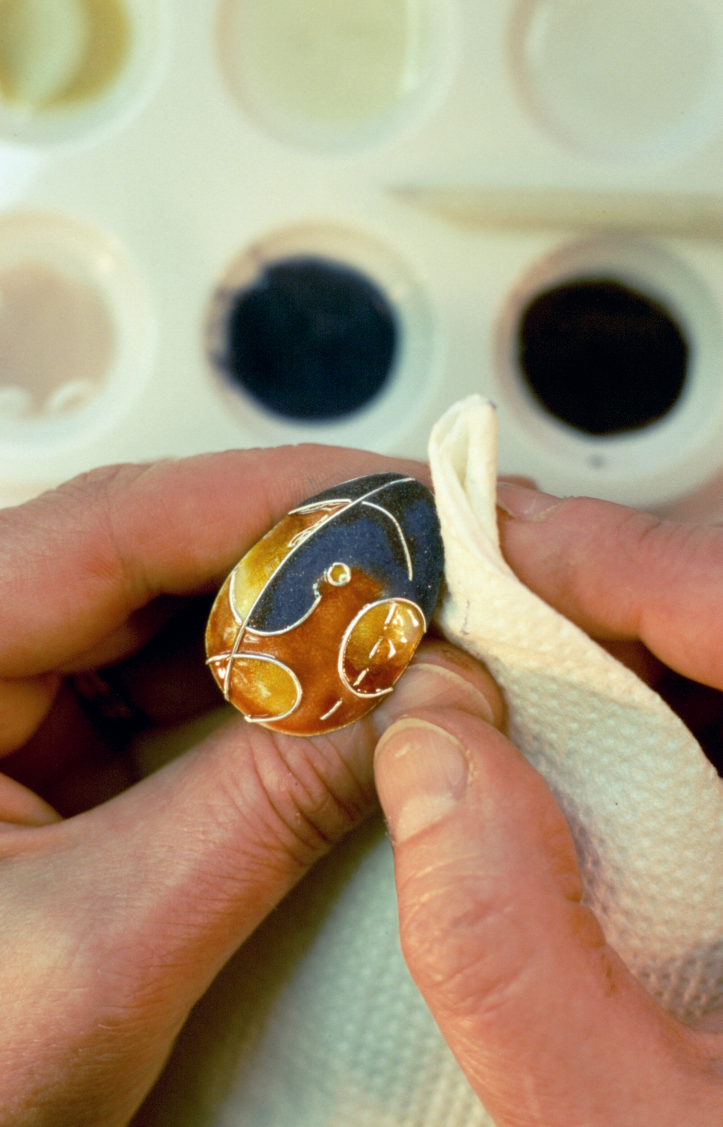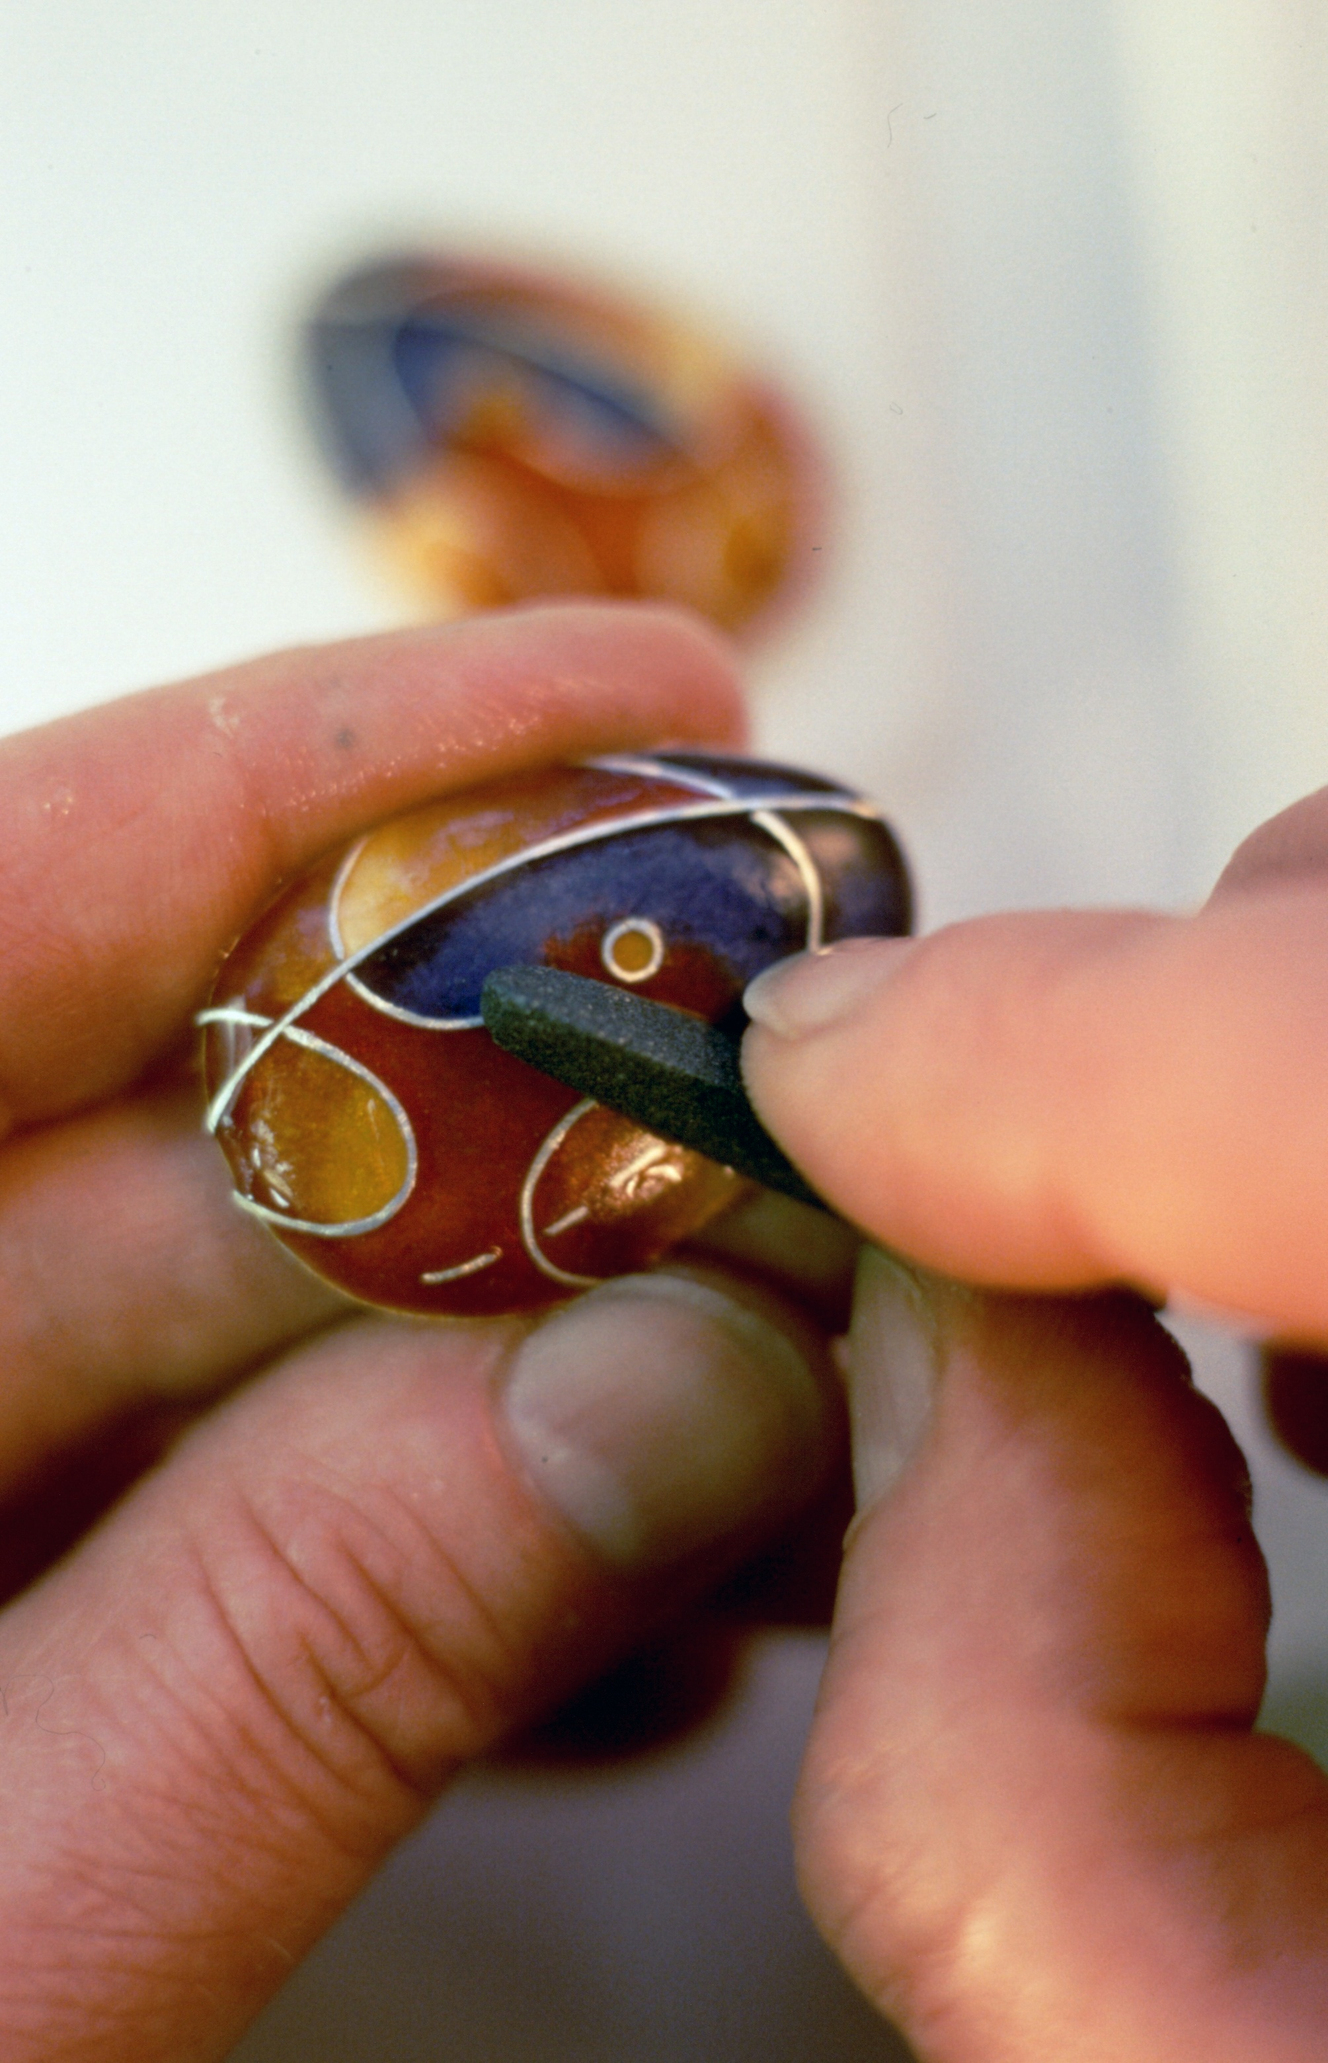

Wet packing the cells with a quill. Tap to expel air pockets Dry off the moisture Stone back to reveal the design

STONING BACK
Once the fired enamel has reached the top of the wires it is stoned back with carborundum stone and / or diagrit to ensure that the piece is uniform and the enamel surface is flush with the embedded wires. The stone is always used with water to grind back the surface. Using water helps prevent particles of stone becoming trapped into the enamel.

It is recommended to use different grades of stone / diagrit to obtain the smoothest finish possible. Firing at this point should be kept to a minimum; just one final firing once the article is stoned back to the wires being the desired option.
The piece should also be rinsed thoroughly under running water with a glass brush to further clean and remove any residue before firing again to re glaze the enamel. The final firing should be high and rapid to give a good gloss finish to the enamel.

Alternatively, using the finest grade diagrit pads, the enamel can be left matt and the wires polished, which is quite effective with opaque designs.

Trouble Shooting
- Protruding wires at the edge:
Ensure the wires at the edges of the piece are trimmed and stoned fully. Keep the edge especially smooth to ensure an even surface. It is important, in order to provide a good fit when setting and minimise stress points.
- Cracks at the edge of the piece:
Watch the edges for cracks when stoning. The edge may have stress points due to the position of the wires or stress in the metal shape. Additionally, consider adding more counter enamel, the piece might be thinner or uneven at the point of cracking. Stone back carefully and re fire, to re fuse the enamel. Take extra care when setting and note the design to prevent the occurrence in other pieces.
- Cracks around wires:
Wires that are badly trimmed can have a raised burr that will be a problem. Some wire shapes can also create tensions in the design. Generally the solution is difficult to advise without seeing the piece, a lot of it is to do with experience – keep note of any design that conflicts and redesign if needed. Check the counter enamel and try adding another layer. You can also try to stone around a wire, re fire, then refill, and continue, but if there is a tension point the piece will be difficult to rescue.
- Gaps and pin holes:
These can form after the piece is stoned and re fired. Stoning back reveals areas that are not full with enamel or air pockets, which have formed and consequently evened out by the process. Re fill with colour or a clear flux and fire. Then re-stone and fire again to finish.
- Wires have moved:
If this happen in the initial firing, and they are not too attached, try removing them and re position. You can trim and the stone back then re apply the wires and continue to enamel.
Wires can move if you over fire. As the enamel becomes molten, the wires move with the flow of colour. If this happens in the final firing little can be done.
- Wires have lifted / not fired into the surface:
If not correctly positioned the wire will not fuse with the enamel. Try and make a good initial fit with the enamel surface.
Press the wire back to the enamel surface and then re fire.
If you are careful you can press the wires very carefully with a pallet knife as the piece is removed from the kiln. Take care with the piece; go gently so that it you don’t distort the metal, and ensure your own safety in regards heat.

- Wires have sunk below the enamel:
If the piece has been over fired and the wires have recessed into the enamel. You can stone back to reveal the wire but you may loose some of the design / depth of colour. There may be unevenness in the design as the wire may have only moved in one area.
- Wires have been stoned away:
This can happen if you are over zealous with stoning when using finer gauge wires. Only add the finest wires in the final firings, and be aware of the depth of enamel you have applied. Use finer grade diagrit with fine cloisonné sections rather than the coarser carborundum, checking the work regularly to determine the level of the wires. If appropriate or possible you can re apply the wire and continued to enamel with a clear flux but this is entirely subjective to the design involved.
- Silver wires have fused with the copper base:
This is called an eutectic reaction. The two metals bond forming an alloy. You can avoid the problem entirely by choosing different options with your metal combinations – enamel on silver using silver or gold wire, or use gold or copper wire over a copper base. Alternatively, make sure you apply a solid base layer (two coats) and do not over fire the piece.
If your wires have fused in this way there is no real remedy. However if you are using opaque, and are lucky, you may possibly stone right back and cover with more opaque enamel, or even foil and then a transparent, but the flaw will prevail if the metals are reacting. Generally the design will be compromised entirely.

Notes:

- Blythe medium flux C1 is used as a base coat and is also useful as a topcoat for finishing / filling the cells.

- If you require an alternative base choose an enamel that is medium or hard in firing temperature, and compatible with any other colours that you are planning to use – if you use a soft colour it will “bubble through” or “climb” around the wires. Also there is a high possibility that the wires will move about if you high fire with a soft colour.

Add your own notes! There are so many variables! Keep a record of your results and observations as they happen!

- ……………………………………………………………………………………………………………………………………

- ……………………………………………………………………………………………………………………………………

- ……………………………………………………………………………………………………………………………………

- ……………………………………………………………………………………………………………………………………

- ……………………………………………………………………………………………………………………………………

- ……………………………………………………………………………………………………………………………………

- ……………………………………………………………………………………………………………………………………

- ……………………………………………………………………………………………………………………………………

- ……………………………………………………………………………………………………………………………………

- ……………………………………………………………………………………………………………………………………

- ……………………………………………………………………………………………………………………………………

- ……………………………………………………………………………………………………………………………………

- ……………………………………………………………………………………………………………………………………

- ……………………………………………………………………………………………………………………………………

- ……………………………………………………………………………………………………………………………………

